

**training support system**

**Software Design Specification**

– Hanoi, August 2022 –

***Record Of Changes***

| **Date** | **A* M, D** | **In charge** | **Change Description** |
| --- | --- | --- | --- |
| 10/Sep | A | AnhPN | Design Database |
| 11/Sep | A | KyNVC | Design Code Packages & Database |
| 11/Sep | A | HoangL | Add Database Description |
| 16/Sep | M | DatLT | Update database design |
| 16/Sep | M | DaiNH | Edit Table Description |
|  |  |  |  |
|  |  |  |  |
|  |  |  |  |
|  |  |  |  |
|  |  |  |  |
|  |  |  |  |
|  |  |  |  |
|  |  |  |  |

*\*A - Added M - Modified D - Deleted*

**Table of Contents**

I. Overview 4

1. Code Packages 4

2. Database Design 4

a. Database Schema 4

b. Table Description 4

# I. Overview

## 1. Code Packages

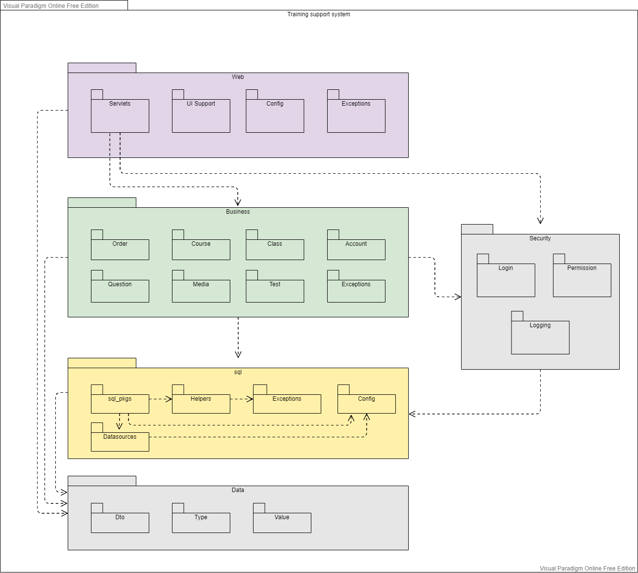

***Package descriptions***

| **No** | **Package** | **Description** |
| --- | --- | --- |
| *01* | *Web::Servlets* | *Handling HTTP requests and responses* |
| *02* | *Web::UI Support* | *Web component management* |
| *03* | *Web::Config* | *Config for web system* |
| *04* | *Web::Exceptions* | *Error handling* |
| *05* | *Business::Order* | *Order management* |
| *06* | *Business::Course* | *Course management* |
| *07* | *Business::Class* | *Class management* |
| *08* | *Business::Account* | *Account management* |
| *09* | *Business::Question* | *Question management* |
| *10* | *Business::Media* | *Media management* |
| *11* | *Business::Test* | *Test management* |
| *12* | *Business::Exceptions* | *Error handling* |
| *13* | *Security::Login* | *Login checking system* |
| *14* | *Security::Permission* | *Permission checking system* |
| *15* | *Security::Logging* | *Logging system* |
| *16* | *Sql::sql_pkgs* | *Data access management* |
| *17* | *Sql::Helpers* | *Sql query support functions* |
| *18* | *Sql::Exceptions* | *Error handling* |
| *19* | *Sql::Config* | *Config for sql* |
| *20* | *Data::Dto* | *Data transfer object* |
| *21* | *Data::Type* | *Data type* |
| *22* | *Data::Value* | *Data value* |

## 2. Database Design

### a. Database Schema

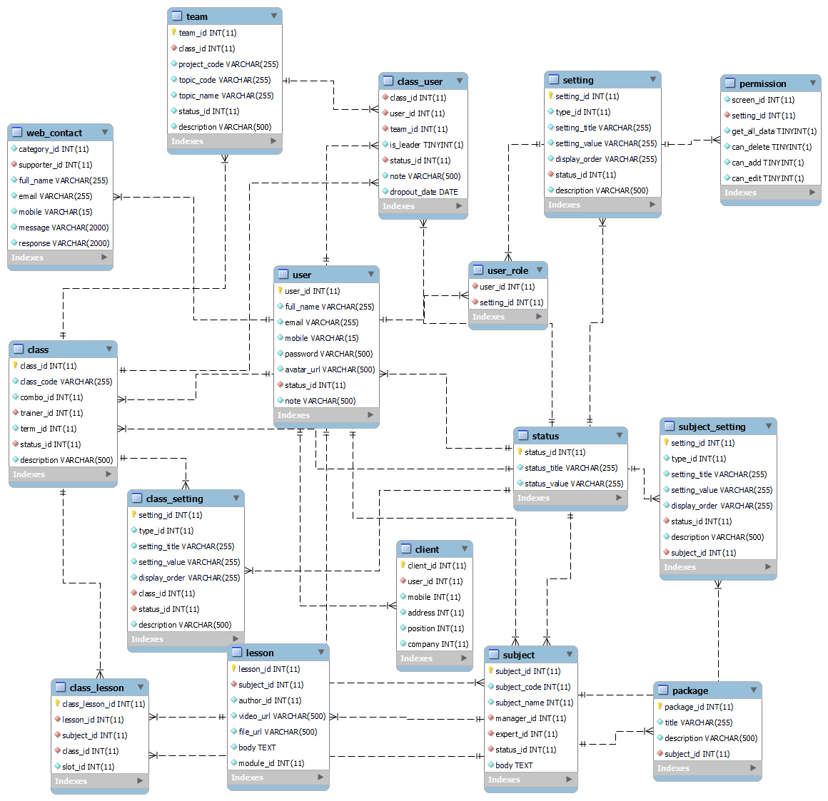

### b. Table Description

| **No** | **Table** | **Description** |
| --- | --- | --- |
| *01* | *user* | *User information* |
| *02* | *user_role* | *Role for user* |
| *03* | *setting* | *Role setting* |
| *04* | *permission* | *Setting permission for role* |
| *05* | *class* | *Classroom detail* |
| *06* | *class_user* | *Classroom of user* |
| *07* | *class_setting* | *Classroom setting* |
| *08* | *class_lesson* | *Lesson of a class* |
| *09* | *lesson* | *Lesson detail* |
| *10* | *team* | *Team in classroom* |
| *11* | *subject* | *Subject detail* |
| *12* | *subject_setting* | *Subject Setting* |
| *13* | *status* | *Status detail* |